PRESS RELEASE

Health Food Industry Launches Legal Action Against EU Legislation.

A joint application for a Judicial Review on the legality of the EU Food Supplements Directive has been lodged with the Court by leading organisations within the health food industry. They are confident that this interesting and important case will succeed in being referred to the European Court of Justice. The National Association of Health Stores (NAHS) and the Health Food Manufacturers Association (HFMA) are also applying for an injunction to stop the Directive coming into effect in this country. The lobby group Consumers for Health Choice (CHC) and nutrition experts the Institute for Optimum Nutrition (ION) are supporting the case.

The Directive 2002/46/EC is designed to harmonise the market across all Member States and will restrict the sale of the most popular higher dose nutrients, such as antioxidant vitamins C, B6 and E and essential minerals including selenium and zinc, in quantities currently used by UK consumers, limiting them to purchasing very small, yet to be determined, doses.

This Directive will affect 41% of UK adults who currently buy over £335 million worth of vitamins and minerals annually. Consumers wishing to maintain their daily nutrient consumption will be forced to make multiple purchases for their usual intake, paying prices several times their current outlay.

In total, over 5,000 popular vitamin and mineral food supplements will be banned and lost forever when the Directive comes into force on 1 August 2005. These products are currently available throughout the UK, accepted as safe by the Regulators and have proven benefits.

The Directive dictates which nutrients and nutrient sources will be allowed, and shows these in the form of a Positive List. There are around 270 ingredients widely used in supplements on the British market that are not included. A very small number of products containing these missing ingredients could remain on the shelves till 2009, but only if the manufacturers compile and submit dossiers proving each ingredient’s safety before the end of July 2005 - costing up to £200,000 per substance.

Ralph Pike, Director of NAHS, said: “Whilst this Directive will be implemented in all EU countries it will be ruinous for the UK. We have a strong and increasing supplements culture and British consumers prefer to buy specialist vitamins and minerals in higher doses than other nations.”

Peter Aldis, Managing Director of Holland & Barrett and current Chairman of HFMA, added: “There is a wealth of evidence supporting the safety and efficacy of essential vitamins and minerals. They have been available as supplements for decades and are the subject of thousands of positive research studies.”

Sue Croft, Director of CHC, stated: “This Directive has to be stopped. It will cause untold misery for millions of consumers if their supplements are restricted. Nobody would deny that regular intake of nutritional supplements acts as an insurance policy, both as an excellent means of maintaining good health and preventing some diseases. Losing our special products will force thousands of people into the doctor’s surgeries, at a time when out health care system is in crisis.”

ENDS
For further information:

Ralph Pike, NAHS – 07866 317760 or 0114 235 3478
Penny Viner, HFMA – 0780 317 0200 or 0208 398 4066
Sue Croft, CHC – 01275 374446
Patrick Holford, ION – 0208 877 9993

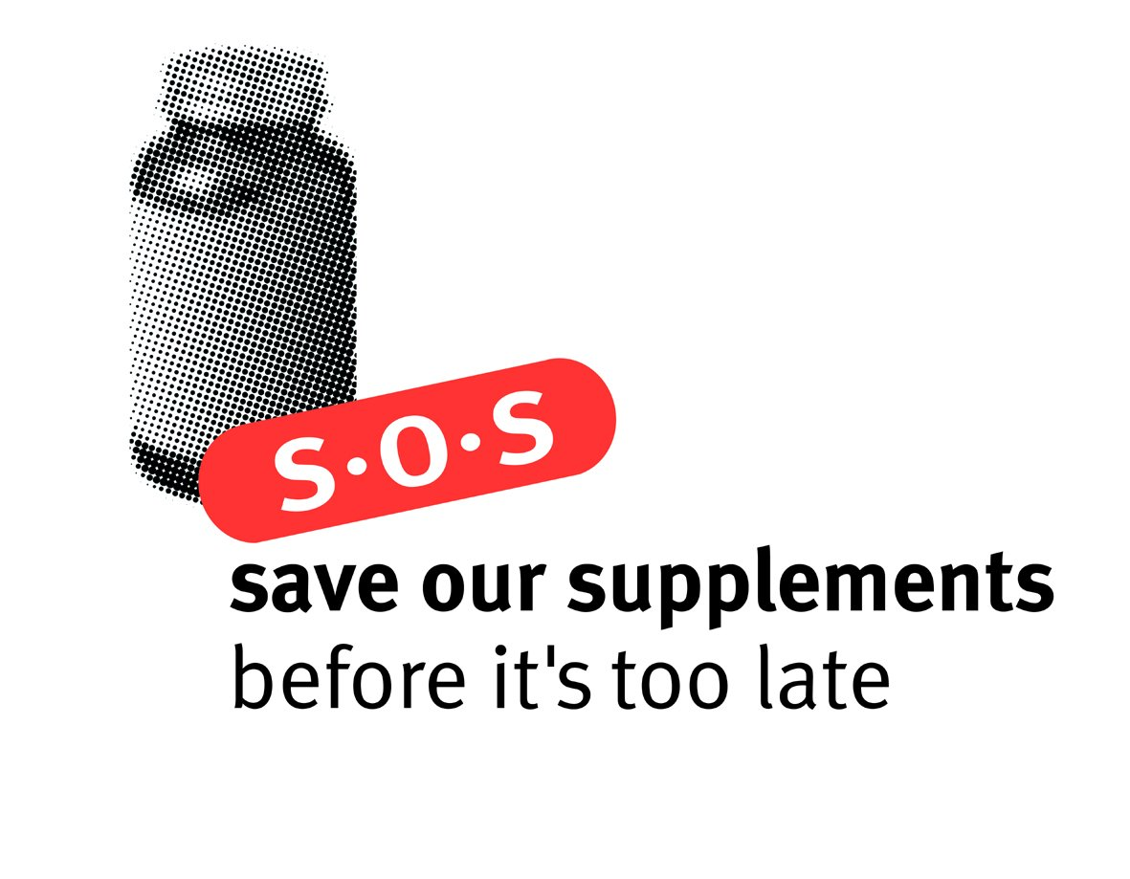

HFMA

