Evidence Of Fraud In The Matter Of Water Fluoridation
by Darlene Sherrell
© 30 June 2003
INTRODUCTION
Is your town fluoridated? Are they considering adding fluoride to the water supply? If so, you should know that the CDC recommends fluoridation based on the Institute of Medicine's fraudulent interpretation of their own references.
Increases in fluoride intake from a variety of sources have made water fluoridation the source of an overdose. However, fluoridation is Dentistry's Sacred Cow and Industry's Sugar Daddy. Artificial water fluoridation utilizes the by-product of fertilizer and/or aluminum production, saving costs involved with toxic waste disposal. It also removes any possibility of a control group for studies on general health effects - and thereby eliminates the threat of lawsuits brought by individuals living downwind from the polluters ... as well as workmens' compensation claims for low-level exposures on the job. Case Study For The 4th Year Course In Ecosystem Health, The University of Western Ontario, Faculty of Medicine and Dentistry
Both children and adults who live in non-fluoridated areas are ingesting just as much fluoride as they did in 1 ppm fluoridated areas sixty years ago - if not more. Adults in fluoridated areas are ingesting enough fluoride to cause the arthritic symptoms of chronic fluoride poisoning. National Research Council - Health Effects of Ingested Fluoride, 1993 & Drinking Water and Health, 1977
Adding fluoride to the water supply will not improve dental health - but it will produce more cases of disfiguring mottled enamel.
The information below is proof of either fraud or incompetence on the part of the CDC with regard to their recommendation for water fluoridation.
Compare the DRI figures with McClure's data - the figures on the right should match the figures on the left - because McClure is the only reference cited for the 1940s.

McClure 1943 |  |  |  | Dietary Reference Intakes
age  years | weight  kg | total intake  mg/day |  | age  years | weight  kg | total intake  mg/day
1-3 | 8-16 | 0.417 to 0.825 |  | 1-3 | 13 | 0.7
4-6 | 13-24 | 0.556 to 1.105
4-8 | 22 | 1.0
7-9 | 16-35 | 0.695 to 1.380 |  | 9-13 | 40 | 2.0
10-12 | 25-54 | 0.866 to 1.715 |  | 14-18 | 57-64 | 2.9 to 3.2
19+ | 61-76 | 1.000 to 1.500 |  | 19+ | 61-76 | 3.1 to 3.8
Symptoms of chronic fluoride poisoning
The United States Public Health Service (USDHHS) describes the early stages in the progression of fluoride poisoning as "sporadic pain and stiffness of joints; chronic joint pain, arthritic symptoms, slight calcification of ligaments, increased osteosclerosis of cancellous bones with or without osteoporosis of long bones." The advanced crippling stage is described as "limitation of joint movement, calcification of ligaments in the neck and vertebral column, crippling deformities of the spine and major joints, muscle wasting, and neurological defects with compression of the spinal cord." Review of Fluoride Benefits and Risks, (1991) page 46
Safety Studies?
There are no diagnostic methods capable of determining whether or not a person's arthritic symptoms were caused by excess fluoride. Researchers and health care providers cannot confirm or report suspected cases of chronic fluoride poisoning until the condition reaches the advanced crippling stage. The claim for safety is based on the absence of reports which would require non-existent diagnostic methods. - Catch 22
What Is The "Adequate" Daily Intake Of Fluoride?
According to the Experts ...
"Dean's initial research established 1.0 mg/L as the approximate concentration of fluoride in drinking water that best prevented caries while keeping unsightly dental fluorosis to a minimum (Dean, 1942) ... As was the case with all fluoride research at that time, drinking water was virtually the only source of measurable fluoride. (Foods usually contained only trace amounts of fluoride.)" Health Effects of Ingested Fluoride, Subcommittee on Health Effects of Ingested Fluoride, Committee on Toxicology, Board on Environmental Studies and Toxicology, Commission on Life Sciences, National Research Council 1993 p. 29-30
From One Source To Four
In 1991 the U.S. Public Health Service said "The daily intake of most adults is about equally divided among food, drinking water, beverages, and mouthwash." Review of Fluoride Benefits and Risks, page 15
During the 1940s fluoride was not added to toothpaste or mouthwash, not widely used in prescription drugs, not present in pesticide residues in fruits and vegetables, and not present in ground meats. Fluoride supplements in tablet or liquid form came later, along with mechanically deboned meats. The machines leave tiny bone fragments - and bones contain fluoride. One cup of ordinary tea now provides upwards of 5 milligrams of fluoride - because air pollution has increased and tea plants absorb large quantities of fluoride. We simply don't know how much fluoride the average child ingests today, or the range in intake. All we know is that in both fluoridated and non-fluoridated areas almost all children have some degree of dental fluorosis. More and more children are developing disfiguring pits and stains on their teeth. Even in non-fluoridated areas you don't see young people with "pearly white" teeth ... most are "eggshell white," and easily stained.
The question is obvious ...
Why Add Fluoride To Water Supplies In The 21st Century?
The CDC's current recommendation to add fluoride to public drinking water supplies is based on the Institute of Medicine's recent publication titled Dietary Reference Intakes for Calcium, Phosphorus, Magnesium, Vitamin D, and Fluoride (1999). According to page 298 of this document: "The cariostatic effect of fluoride is a strong indicator for an Adequate Intake (AI) of the ion. Figure 8-1 summarizes the results of the pioneering epidemiological studies of the relationship between the concentration of fluoride in drinking water and dental caries and enamel fluorosis (mottling) (Dean 1942). ... reduction in the average number of dental caries per child was nearly maximal in communities having water fluoride concentrations close to 1.0 mg/liter. This is how 1.0 mg/liter became the "optimal" concentration. That is, it was associated with a high degree of protection against caries and a low prevalence of the milder forms of enamel fluorosis."
NOTE: Dietary Reference Intakes contains only part of McClure's data ... the intake figures for older children and adults have been ignored by the Institute of Medicine.
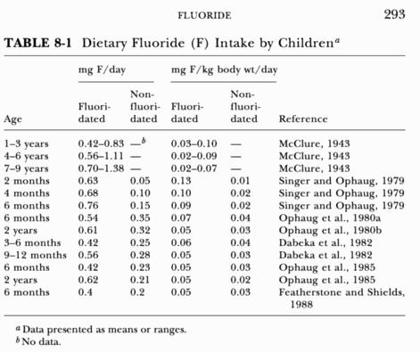
Their only reference for the 1940s - before other sources of fluoride became widely available - is McClure, Frank J., Ingestion of fluoride and dental caries - quantitative relations based on food and water requirements of children 1 to 12 years old, American Journal Diseases of Children, 66:362, 1943.
McClure's paper contains two tables showing intake figures for children of various ages. The more detailed Table 3, which appears directly below, and the summary Table 5. Note that the maximum calorie and water requirements for children age twelve are about the same as the requirements for mature adults.
McClure - Table 3. - Estimated Daily Intake of Fluorine from Drinking Water Containing 1 part per Million of Fluorine and from Food Containing 0.1 to 1 Part per Million of Fluorine in the Dry Substance
Age (years) | 1 to 3 | 4 to 6 | 7 to 9 | 10 to 12
Energy Allowance (calories) | 1200 | 1600 | 2000 | 2500
Water Requirement (cc.) | 1200 | 1600 | 2000 | 2500
Drinking water consumption
(1) When water drunk is equal to 25 per cent of the total daily water requirement and (a) 10 per cent and (b) 20 per cent of the total water content of the food is of drinking water origin, the total daily consumption of drinking water would equal:
(a) | 390 cc | 520 cc | 650 cc | 812 cc
(b) | 480 cc | 640 cc | 800 cc | 1000 cc
(2) When water drunk is equal to 33 per cent of the total daily water requirement and (c) 10 per cent and (d) 20 per cent of the total water content of the food is of drinking water origin, the total daily consumption of drinking water would equal:
(c) | 480 cc | 640 cc | 800 cc | 1000 cc
(d) | 560 cc | 746 cc | 933 cc | 1166 cc
Total daily fluoride ingested from drinking water containing 1 part per million of fluorine under the preceding conditions of water ingestion would equal:
In water intake (a) | 0.390 mg | 0.520 mg | 0.650 mg | 0.810 mg
In water intake (b) and (c) | 0.480 mg | 0.640 mg | 0.800 mg | 1.000 mg
In water intake (d) | 0.560 mg | 0.745 mg | 0.930 mg | 1.165 mg
Total dry substance in daily food allowance when 1 Gm of dry substance of the food furnished 4.5 calories of energy
Total daily intake of dry substance | 265 Gm | 355 Gm | 445 Gm | 555 Gm
Fluorine ingested daily in food in which the dry substance of the food contained the following concentrations of fluorine:
(a) 0.10 part per million | 0.027 mg | 0.036 mg | 0.045 mg | 0.056 mg
(b) 0.20 part per million | 0.053 mg | 0.071 mg | 0.089 mg | 0.111 mg
(c) 0.50 part per million | 0.133 mg | 0.178 mg | 0.223 mg | 0.278 mg
(d) 1.00 part per million | 0.265 mg | 0.360 mg | 0.450 mg | 0.560 mg
Estimated total daily fluorine ingested in food and drinking water:
Food (a) plus water (a) | 0.417 mg | 0.556 mg | 0.659 mg | 0.866 mg
Food (b) plus water (a) | 0.443 mg | 0.591 mg | 0.739 mg | 0.921 mg
Food (c) plus water (a) | 0.523 mg | 0.693 mg | 0.872 mg | 1.088 mg
Food (d) plus water (a) | 0.653 mg | 0.880 mg | 1.100 mg | 1.370 mg
Food (a) plus water (b) or (c) | 0.507 mg | 0.676 mg | 0.845 mg | 1.056 mg
Food (b) plus water (b) or (c) | 0.533 mg | 0.711 mg | 0.889 mg | 1.111 mg
Food (c) plus water (b) or (c) | 0.613 mg | 0.818 mg | 1.023 mg | 1.278 mg
Food (d) plus water (b) or (c) | 0.745 mg | 1.000 mg | 1.250 mg | 1.560 mg
Food (a) plus water (d) | 0.587 mg | 0.781 mg | 0.975 mg | 1.221 mg
Food (b) plus water (d) | 0.613 mg | 0.816 mg | 1.019 mg | 1.276 mg
Food (c) plus water (d) | 0.693 mg | 0.923 mg | 1.153 mg | 1.443 mg
Food (d) plus water (d) | 0.825 mg | 1.105 mg | 1.380 mg | 1.725 mg
McClure wrote:
"The figures for water consumption in table 3 may be compared with other estimates and actual measurements of water drinking. Macy found that the total amount of water consumed daily by children 8 to 12 years of age ranged from 1,658 to 1,745 cc; 449 to 568 cc of these amounts, i.e., about 25 to 30 per cent, was ingested as drinking water. Richter and Brailey regarded 2,400 cc as a good average for water intake daily by an average man weighing 65 Kg."
"The estimates of fluorine intake shown in table 3 may be compared with the actual fluorine content of an average diet consumed by a man, as determined by Machle, Scott, and Largent. The actual fluorine intake based on a nine month study was approximately 0.45 mg. daily. The drinking water contained no fluorine, all the dietary fluorine being ingested in food and beverages. It was noted that almost twice as much fluorine was contributed by fluids (tea, coffee, milk, beverages and beer) as was present in the solid food. As would be expected, the consumption of iced tea during the summer seemed to account for a notable elevation in intake of fluorine."
"In table 5 are summary estimates of fluorine intake such as appear in table 3. The quantity of fluorine ingested by children from drinking water containing 1 part per million of fluorine according to these estimates will equal approximately 0.5 to 1 mg. of fluorine daily. This quantity of water-borne fluorine plus fluorine contained in foods may bring the total amount of fluorine contained in the average diet up to 1 to 1.50 mg. ..."
. . . NOTE: 0.45 mg fluoride daily in a non-fluoridated area would be about 0.16 mg from food and "almost twice as much" 0.29 mg from beverages.
However, over the years, background levels of fluoride have increased dramatically, so that even where the water contains very little fluoride, the diet may contain several times more than the recommended 1 milligram per day.
The next figures show the amount of fluoride found in typical diets in several U. S. cities in 1974. These figures do not include drinking water or non-meal foods and beverages.
Location | Water | Dietary Fluoride
Corvalis, OR | 0.060 ppm | 3.44 mg/day
Milwaukee, WI | 0.85 ppm | 3.41 mg/day
Cleveland, OH | 1.27 ppm | 3.05 mg/day
Tuscaloosa, AL | 0.76 ppm | 2.94 mg/day
Madison, WI | 1.11 ppm | 2.88 mg/day
Iron Mountain, MI | 0.08 ppm | 1.03 mg/day
Kramer, Osis, Wiatrowski & Spencer, Dietary Fluoride In Different Areas
in the United States, American Journal of Clinical Nutrition - 27:590-594 (1974)
According to the BabyCenter Medical Advisory Board: One cup of black tea now provides 7.6 mg fluoride. http://www.babycenter.com/refcap/674.html#3.
Something had to be done. By 1990 the mildest forms of dental fluorosis - not visible except to the trained eye of the dental examiner - had increased from about 10% to more than 80% in Augusta, Georgia; and moderate-to-severe fluorosis was found in 14% of the children. Health Effects of Ingested Fluoride, NAS/NRC 1993, p. 37
In order to protect water fluoridation this increase in dental fluorosis has been blamed on toothpaste rather than increased dosage from foods and beverages.
Under the influence of Ian Munro (American Council on Science and Health) as well as Herschel Horowitz (American Dental Association), the Institute Of Medicine tried to make it look as though adults in fluoridated areas have always ingested 3 or 4 milligrams of fluoride per day - and children age 9-13 have always ingested 2 mg/day. In short, they cooked the books. If adults are ingesting up to 4 mg/day in fluoridated areas with 2500 calories and 2500 cc of water, then so are older children who have the same nutritional requirements and consume the same foods and beverages. It is illogical to assume there haven't been similar increases in dosage among younger children - causing more dental fluorosis, and possibly more cavities - even in non-fluoridated areas. We can't blame it all on toothpaste.
Compare the DRI figures with McClure's data - look at the bottom line and keep in mind that McClure is their only reference for the 1940s.
McClure 1943 |  |  |  | Dietary Reference Intakes
age  years | weight  kg | total intake  mg/day |  | age  years | weight  kg | total intake  mg/day
1-3 | 8-16 | 0.417 to 0.825 |  | 1-3 | 13 | 0.7
4-6 | 13-24 | 0.556 to 1.105 |  | 4-8 | 22 | 1.0
7-9 | 16-35 | 0.695 to 1.380 |  | 9-13 | 40 | 2.0
10-12 | 25-54 | 0.866 to 1.715 |  | 14-18 | 57-64 | 2.9 to 3.2
19+ | 61-76 | 1.000 to 1.500 |  | 19+ | 61-76 | 3.1 to 3.8
How Did 1.5 Become 3.8?
Is It Fraud Or Incompetence?
The Institute of Medicine has applied the same 0.05 mg/kg/day figure to people of all ages. This is wrong. In terms of calories per pound of body weight, the older we get the less food we need to maintain body weight. An infant needs far more calories per pound of body weight than an adult. Similarly, water intake for mature adults is about the same as for older children.
The following is from the National Research Council's 1993 review, Health Effects Of Ingested Fluoride pages 31-32:
"The concept of an optimal dose goes back to the early days of fluoride research in dentistry. In 1943, the normal daily fluoride intake of children 1-12 years old was estimated to be 0.4 to 1.7 mg, which provided an average intake of fluoride at 0.05 mg/kg of body weight per day (McClure, 1943). Actual fluoride intake for an individual depended on age, diet, and fluoride content of water. That estimate somehow evolved into a recommendation (Farkas and Farkas, 1974) and then to apparent acceptance of 0.05-0.07 mg/kg per day as an optimal dose (Ophaug et al., 1980a).
"Despite its dubious genesis, that dose might be a fair estimate, based on empirical evidence, of the upper limit for fluoride intake in children to minimize fluorosis (Burt, 1992). If all fluoride intake comes from drinking water, that dose for a child weighing 10 kg (an average 1-year-old) would be ingested in 0.5-0.7 L of water fluoridated at 1.0 mg/L. For a child weighing 22 kg (an average 6-year-old), it would be ingested in 1.1-1.5 L of water. Because the scientific base is weak, however, the range of 0.05-0.07 mg/kg should not be referred to as an optimal dose, and it should not be considered more than a guide to the upper limit of intake for minimizing fluorosis.
"The intake of fluoride that leads to clinically detectable dental fluorosis, relative to body weight at different stages of growth, still requires considerable clarification. Forsman (1977) stated that a daily intake of 0.1 mg/kg was sufficient to cause dental fluorosis, an estimate that was later revised downward to 0.04 mg/kg (Baelum et al., 1987). ... Further research is necessary to clarify the relation between fluoride intake in childhood and development of dental fluorosis. Recent estimates of daily intake of fluoride from food and drink by North American children up to 2 years of age are 0.01-0.16 mg/kg in areas without fluoridation and 0.03-0.13 mg/kg in areas with fluoridation (Burt, 1992).
"Because dental fluorosis is a dose-response condition (Myers, 1983), severity ranges from barely discernible, even to a trained observer, to the most severe manifestations of stained and pitted enamel."
1953 - "Exclusive of drinking water, the average diet in the United States is calculated to provide 0.2 to 0.3 milligram of fluoride daily. ... drinking water ... can provide an optimal internal supplement of approximately one-half to 1 milligram of fluoride per day." The problem of providing optimum fluoride intake for prevention of dental caries, Food and Nutrition Board, Division of Biology and Agriculture, National Academy of Sciences, National Research Council, Pub. #294
The Institute Of Medicine Cooked The Books To Protect Fluoridation
This is nothing more than an attempt to show that 1.0 ppm is still the optimum for dental health, in spite of the fact that "The daily intake of most adults is about equally divided among food, drinking water, beverages, and mouthwash." Review of Fluoride Benefits and Risks, page 15
But will the Institute of Medicine correct their error? Or will they continue to recommend daily doses of fluoride known to cause disfiguring mottled enamel - and then blame it on toothpaste. Will they consider life-long exposures known to result in crippling arthritic symptoms?
What Does This Mean For Adults?
1977 - "Recent studies indicate that the total intake of fluoride is as high as 3 mg/day rather than the earlier figure of 1.5 mg/day, primarily because of increases in the estimated levels of fluoride in food. (1970) Balance data presented by Spencer also suggest a higher retention by bone, nearly 2 mg/day rather than the 0.2 mg/day indicated earlier. ... These findings are important . . . a retention of 2 mg/day would mean that an average individual would experience skeletal fluorosis after 40 yr, based on an accumulation of 10,000 ppm fluoride in bone ash." Drinking Water and Health, Safe Drinking Water Committee, National Academy of Sciences, NAS/NRC, pages 371-372
"Eighty to one hundred percent of ingested fluoride is absorbed from foods and beverages. The fractional retention or balance of fluoride at any age depends on the quantitative features of absorption and excretion. For healthy, young, or middle-aged adults, approximately 50 percent of absorbed fluoride is retained by uptake in calcified tissues, and 50 percent is excreted in the urine. For young children, as much as 80 percent can be retained owing to increased uptake by the developing skeleton and teeth." Dietary Reference Intakes, NAS/NRC/IOM 1999
1991 - Crippling Skeletal Fluorosis with a bone ash concentration of 6,000 to 7,000 ppm fluoride is described by the U.S. Public Health Service as sporadic pain and stiffness of joints. Above 7,500 ppm the symptoms are "chronic joint pain, arthritic symptoms, slight calcification of ligaments, increased osteosclerosis/cancellous bones, with/without osteoporosis of long bones." With more than 8,400 ppm in bone ash the symptoms are described as "limitation of joint movement, calcification of ligaments/neck, vert. column, crippling deformities/spine & major joints, muscle wasting, neurological defects/compression of spinal cord." Review of Fluoride Benefits and Risks, page 46
May 1978 - "This pattern of a higher crude death rate in the cities with fluoridated water supplies was apparent for all categories of death except for those by accidental means and suicide." Erickson, J. David, Mortality in Selected Cities With Fluoridated and NonFluoridated Water, New England Journal of Medicine
Although this study has been offered as evidence for the safety of fluoridation, the basic facts are clear in the statement above. To remove the stigma, the author adjusted his data based on people in one group of cities having an average of 11.5 years of formal education vs. the other group with an average of 12 years. The only way to remove the obvious connection between cancer and fluoridation was to claim that graduating from high school is the most important factor in cancer prevention - more important than one's age, income, or occupation. In other words, this author claims that working in a chemical factory or handling toxic waste is less hazardous to your health than dropping out of high school six months before graduation. He worked for the government. It was his job to protect water fluoridation.
The Institute Of Medicine Also Cooked The Books
Regarding "Tolerable" Intake
The Institute of Medicine (IOM) increased the "tolerable" daily intake of fluoride - from 4 mg/day (1989 RDAs) to 10 mg/day (DRI 1999). The reference cited by IOM is Hodge 1979. However, Hodge's reference is an earlier article by Hodge in which he cites Largent 1961. Largent mentioned just one 30-year old individual in Texas who used some high fluoride water for only eight years. The water contained so much magnesium and sulfates that few could stand the taste. According to Largent, "this supply was not used extensively for drinking purposes, and other sources of water were being explored."
IOM described this one man in one town in Texas as "communities in the United States" as though it involved more than one person, more than one town, and something more than a 45-day observation - but no real studies. Largent, E.J. Fluorosis. The health aspects of fluorine compounds (1961) Ohio State University Press, Columbus, Ohio.
IOM also misrepresented Hodge 79 and NAS/NRC 1993 regarding the degree of skeletal fluorosis which can develop after 10 years at 10 mg/day. Hodge actually said that crippling skeletal fluorosis occurs with 10 to 25 mg/day for 10 to 20 years. NAS/NRC said "Crippling skeletal fluorosis might occur in people who have ingested 10-20 mg of fluoride per day for 10-20 years." Health Effects of Ingested Fluoride, page 59
Crippling is not a "mild" form of skeletal fluorosis, but "mild" is the term IOM used in Dietary Reference Intakes.
What About Those Hundreds Of Safety Studies?
According to the CDC, the safety of water fluoridation "is supported by extensive peer-reviewed scientific research." However, no one seems to be able to name even one legitimate safety study. In fact, there were no studies capable of identifying people still in the pre-crippling stages of skeletal fluorosis - because there has been no method available in the United States to distinguish between arthritic symptoms caused by fluoride and arthritic symptoms caused by something else. The CDC won't name a study. The National Center For Fluoridation Policy and Research can't name a study. Their Board of Science, Technology, and Policy Advisors includes Stephen Barrett, M.D., Chairman, Board of Directors, Quackwatch, Inc., Allentown, Pennsylvania; Robert H. Dumbaugh, D.D.S., M.P.H., Director, Division of Public Health Dentistry, Palm Beach County Health Department, West Palm Beach, Florida; Thomas G. Reeves, M.S., P.E., National Fluoridation Engineer, Division of Oral Health, U. S. Centers for Disease Control & Prevention, Atlanta, Georgia; and a number of others with similar credentials - yet none of these people can name even one legitimate safety study.
Stephen Barrett sued me for $100,000.00 plus costs after I said he couldn't name "any studies which indicate that researchers used methods capable of detecting cases of chronic fluoride poisoning - but failed to find them - in any fluoridated U.S. cities in the past."
When U.S. District Court Judge Michael R Hogan (Oregon) asked him if he could name a study, Dr. Barrett admitted he could not.
The judge ruled in my favor. (Civil No. 99-813-HO)
It's a scam. Children who live in non-fluoridated areas are getting more than their "optimum" daily dose of fluoride. Adding more is just asking for trouble.

IMAGES
The University of Western Ontario,
Faculty of Medicine and Dentistry - link to www.med.uwo.ca
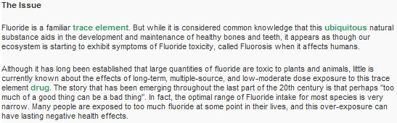
University of Western Ontario,
Faculty of Medicine and Dentistry - link to www.med.uwo.ca
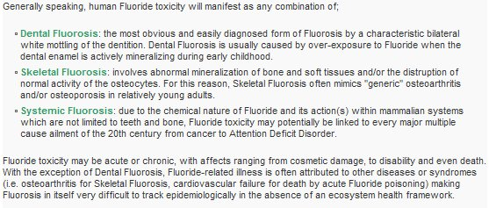
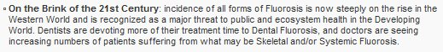
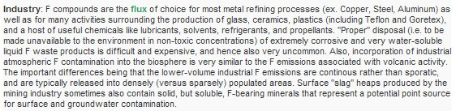
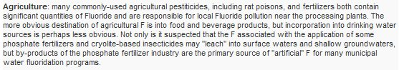
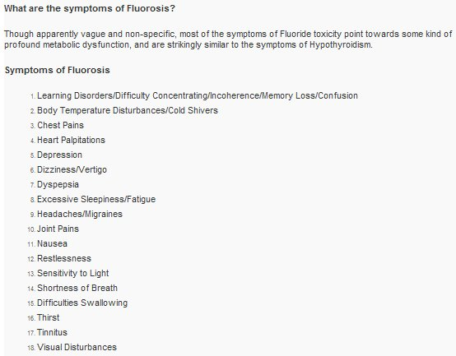

60 years ago the average diet contained 0.2 to 0.3 mg/day
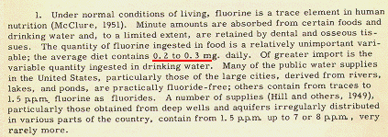
Report of the Ad Hoc Committee on the Fluoridation of Water Supplies,
Division of Medical Sciences, National Research Council, Nov. 29, 1951

Health Effects of Ingested Fluoride - link to www.nap.edu
Health Effects of Ingested Fluoride - page 31
up to age two the daily intake was 0.01 to 0.16 mg/kg/day without fluoridation by 1990
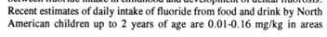
Health Effects of Ingested Fluoride - page 32
up to age two the daily intake was 0.03 to 0.13 mg/kg/day with fluoridation by 1990
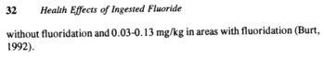
Health Effects of Ingested Fluoride - page 34
Severe Dental Fluorosis
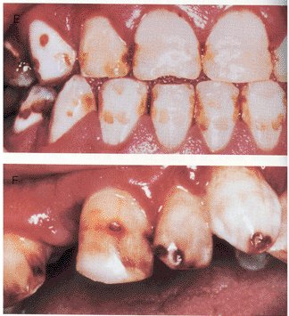
Health Effects of Ingested Fluoride - page 35
60 years ago only 10% to 12% had mildest form of dental fluorosis
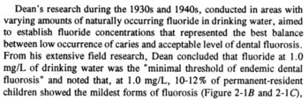
Health Effects of Ingested Fluoride - page 45
increasing fluoride intake may result in more cavities
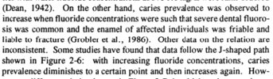
Health Effects of Ingested Fluoride - page 48
mottled enamel may be more than a cosmetic defect
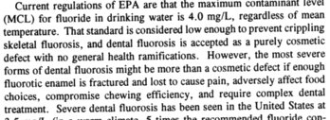
Health Effects of Ingested Fluoride - page 59
crippling skeletal fluorosis with as little as 10 mg/day for 10-20 years
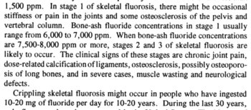

Drinking Water and Health - link to www.nap.edu
Drinking Water and Health - page 371
by the 1970s total daily dosage had increased from 1.5 mg/day to 3 mg/day
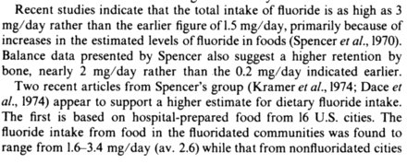
Drinking Water and Health - page 372
for the average individual a retention of 2 mg/day is enough to cause crippling skeletal fluorosis
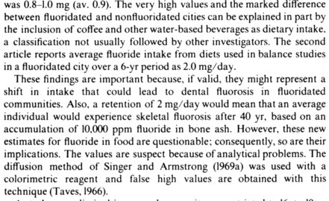
Drinking Water and Health - page 373
many industries pollute the air with fluoride dusts and gases
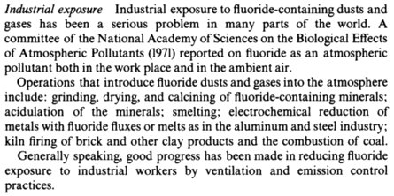

Dietary Reference Intakes - link to www.nap.edu
Dietary Reference Intakes - page 289
50% or more of ingested fluoride is retained
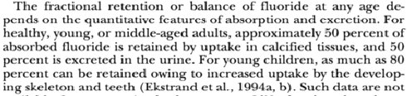
Dietary Reference Intakes - page 301
mg/kg/day figures for children are higher than the mg/kg/day figures for adults
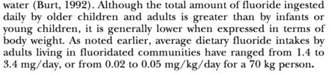
Dietary Reference Intakes - page 311
more than twice as much dental fluorosis as in the 1940s
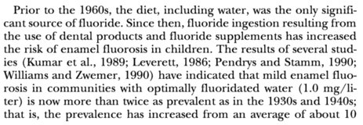
Dietary Reference Intakes - page 312
dental fluorosis rates increased from 1% to 10% with 0.3 ppm
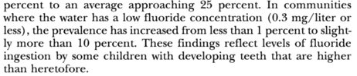

Recommended Dietary Allowances (1989) page 284 - link to www.nap.edu
note that for adults ... 1.5 mg/day is adequate and 4 mg/day is just tolerable
(this tolerable 4 mg/day intake figure was based on the erroneous belief that crippling skeletal fluorosis requires a daily intake of 20-80 mg for 10 to 20 years. This error was corrected in 1993 in Health Effects of Ingested Fluoride after a series of letters between NAS/NRC/IOM and Darlene Sherrell, who pointed out the fact that the author of the error - Harold Hodge - had corrected his error in 1979. Hodge's new estimate was 10 to 25 mg/day for 10 to 20 years)
for children over age seven ... 1.5 mg/day is adequate and 2.5 mg/day is just tolerable
SUMMARY TABLE
Estimated Safe and Adequate Daily Dietary Intakes
of Selected Vitamins and Minerals
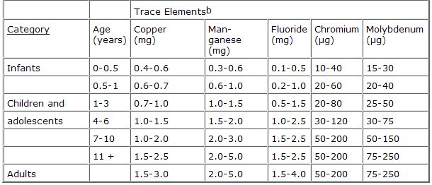

Hodge's table adapted from Largent 1961 - only one 30-year old man
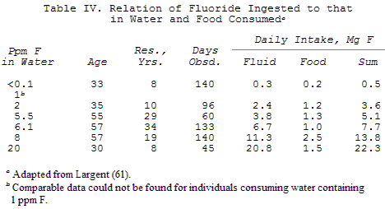
Hodge, H.C. and Smith, F. A, Minerals: Fluorine. Advances in Chemistry: Symposium on Dietary Chemicals in Relation to Dental Caries, Dr. Robert S. Harris, editor. (papers compiled from a symposium held in 1966)
Hodge cites Largent, E.J., Fluorosis. The health aspects of fluorine compounds (1961) Ohio State University Press, Columbus, Ohio.

Adults ingest their "optimum" daily dose of fluoride when drinking water contains only 0.1 ppm fluoride. Without evidence that children are ingesting less than their "optimum" daily dose, adding fluoride to the water supply is irresponsible. The image below is from the Environmental Assessment for Ft. Detrick, Maryland.
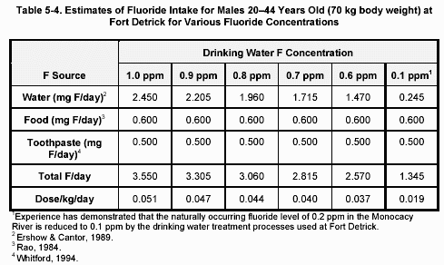
In 1971, before scientists became aware of significant increases in daily fluoride intake, NAS/NRC had this to say: "For the average U.S. adult not working in a fluoride industry and using a water supply containing 1 mg/liter, the approximate daily intake is 1.2 - 1.5 mg of fluoride." Biologic Effects of Atmospheric Pollutants - FLUORIDES, Committee on Biologic Effects of Atmospheric Pollutants, Division of Medical Sciences, National Academy of Sciences, Washington, D.C., 1971.

