Natural Health Products Bill Goes to Committee
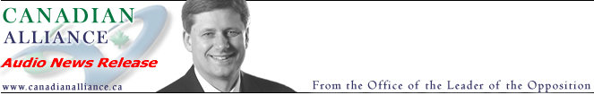
For Immediate Release
October 23, 2003

Natural Health Products Bill Goes to Committee

OTTAWA - Dr. James Lunney, MP for Nanaimo-Alberni, made the following statement in response to passage at second reading of his Private Members' Bill C-420, An act to amend the Food and Drugs Act:

"Drug-style regulation is not appropriate for Natural Health Products. They're not patentable.
Health Canada has obstructed effective, low-risk Natural Products, removing them from the market, even shutting down promising research under the authority of antiquated, unscientific clauses in the Food and Drugs Act. Bill C-420 would remove these barriers and still provide good manufacturing practices, inspection, quality assurance and evaluation of health claims. Members from all parties want this matter reviewed by the Health Committee."

The vote for C-420 passed by a margin of 124 to 85, with all opposition parties and many government Members showing support. The bill will be referred to the Standing Committee on Health, who will examine the bill, hear from witnesses, and consider amendments before it returns to the House.

-30-

For more information:
Dr. James Lunney, MP
613.992.5243

